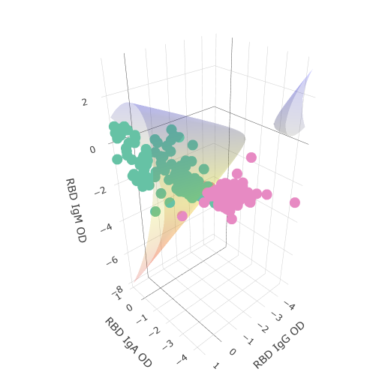**SeroNIST v1.0 User Manual**

**Primary Author:**

Stephen Tennyson

[Stephen.tennyson@nist.gov](mailto:Stephen.tennyson@nist.gov)

**Theory Points of Contact:**

Paul Patrone

[Paul.patrone@nist.gov](mailto:Paul.patrone@nist.gov)

Anthony Kearsley

[Anthony.kearsley@nist.gov](mailto:Anthony.kearsley@nist.gov)

**Downloading, Updating & Starting the Application**

A. Download:

1. Download the zip file for SeroNIST to your device.
2. Locate the download, right-click, and select “Extract all”.
3. Select the C:/ directory on your device for the extract location. Ensure that the title of the extracted folder remains “SeroNIST”.

B. Updating SeroNIST:

1. If you have previously followed Section A and are given a source.zip file to update SeroNIST, you do not need to repeat the above steps again.
2. Download the source.zip file, right click and Extract all.
3. In your SeroNIST directory, backup the existing source folder to a different folder, rename it, or delete it.
   1. We recommend saving previous source folders into a dedicated backup folder.
4. Copy the new, extracted source folder to the location of the previous source folder.
5. Ensure that the folder name remains “source”.
6. In the event an update has usability issues, you can roll back to the last backup of your source folder.

C. Run SeroNIST:

1. Once extracted, enter the folder and double click the “run.bat”file.
2. A black terminal will appear while the application loads.
   1. This window may appear for a variable 2-3 minutes on initial load times.

**Development Notes (April 2024)**

A. Usability

This version of SeroNIST is a beta version that is still under development. Certain features, known issues, and the overall usability of the application may be limited between software updates.

B. Update Schedule

Updates can be expected quarterly, time and funding permitted. Updates will be accompanied by a changelog to track changes between versions of SeroNIST.

C. Error and Bug Reporting

1. Every time SeroNIST is ran, a log file called “ShinyApp.log” is created and stored in the SeroNIST directory.
2. If the app force closes or displays unexpected results or behavior, make note of the sequence of actions that led to that outcome and location within the app
3. Send us an e-mail with the following:
   1. The ShinyApp.log file
   2. A brief description of the error
   3. Notes described in Step 3
   4. Please do not include raw datafiles unless they are publicly available and only after contacting us first. While NIST is committed to protecting confidential and human subjects information, we cannot necessarily accept data without prior transfer agreements in place.

Note: Because the ShinyApp.log file is overwritten with each session, you should rename the ShinyApp.log file after each error occurs. If storing multiple error files, it can help to systematically rename the file to with the date and brief error description.

Examples)

* “ShinyApp_01012024_ *trainingTab_rawDataPlotNotDisplaying*.log”
* “ShinyApp_*exportTab_submitButtonError*.log”.

D. Troubleshooting Known Issues

The following section is specific to this version of SeroNIST (v1.0). All known issues and troubleshooting procedures are subject to change with each update. This section contains a brief description of known issues that may arise from expected use of SeroNIST, along with troubleshooting measures (if available) to resolve or avoid the issue. If your issue cannot be found in this section, please refer to the Error and Bug Reporting steps listed above to report your issue to developers.

1. Assigning classes by row selection (manually) paired with renaming the class using the empty textbox may cause a force close:
   1. Brief Description:

Renaming classes is an optional feature that allows users to rename the original name of a given class within a datafile to one chosen by the user. Using the rename feature in conjunction with the manual row select feature, for both Data Import & Training and Test Data tabs may result in SeroNIST force closing. This bug is known to occur specifically for Test Data tab and occasionally for the Training Data tab.

* 1. Expected Functionality:

Renaming classes should perform with all features without interruption and apply the rename to all downstream instances of the class or antigen being renamed.

* 1. Troubleshoot:
     1. To avoid a force close, refrain from combining the row select feature for Class assigning with renaming the class.

1. Assigning Antigens that are red highlighted will cause the app to force close:
   1. Brief Description:

Selecting antigens in both the Data Import & Training and Test Data tabs involves making a selection from a dropdown menu of available columns from the data. Certain columns are highlighted in red if they contain non-numeric data. Selecting these red antigen columns and proceeding with the analysis may cause SeroNIST to force close without warning.

* 1. Expected Functionality:

Selecting a red-highlighted column should convert any non-numeric data to numeric data so that SeroNIST may continue without interruption.

* 1. Troubleshoot:
     1. If your antigen column appears in red, ensure that the original datafile being uploaded does not have non-numeric data interleaved with numeric data. Non-numeric data can include words, NAs, numeric data with character data mixed in between, and possibly numeric data written in scientific notation.
     2. You may attempt to assign classes using the row select tool to avoid selecting data that is non-numeric. This troubleshoot measure is untested.

1. Modifying settings that have already been committed may result in force close:
   1. Brief Description:

Once the analysis pipeline has been completed (Import, Select Antigens, Assign Classes, Train/Analyze), users may unexpectedly crash SeroNIST by modifying previously adjusted settings and attempting to run through the pipeline again. While some users may be able to go back and modify certain things like class assignments and assigned antigens, dimensionality, or renaming with ease, backtracking on certain things like optimization routines may cause the app to force close.

* 1. Expected Functionality:

Users should be able to run through their analysis and go back to modify certain settings to see how their analysis has changed to encourage exploratory analysis.

* 1. Troubleshoot:
     1. To start a new search, return to the Data Import & Training Tab and upload a new file. This will clear all previous work and all outputs downstream.
     2. Close SeroNIST after each completed search and open a new instance of SeroNIST to conduct each future search.
     3. If you wish to try your luck conducting multiple analyses in a single session, avoid using features with known issues described in this section such as class renaming and using non-numeric antigen data.

1. Plots may resize inappropriately when window size is adjusted:
   1. Brief Description:

Once certain plots are rendered, particularly plots with boundaries, then adjusting the size of the window may cause the plot to render to a format that is not easily viewable. This issue only occurs with the plot tab that is currently selected.

* 1. Expected Functionality:

Adjusting the window size of SeroNIST should not cause irreversible damage to already rendered plots, and if so, the original plot should be restored to avoid loss of work.

* 1. Troubleshoot:
     1. If plots are corrupted because of window size adjustment, users can attempt to re-render the plot by pressing the last button in the pipeline that was used to render the plot.
     2. Users may be forced to start a new session and repeat the last sequence of actions to restore the plot.
     3. Unfortunately, tools in the plot toolbar such as restore view or going to last saved have no effect.

1. Color assignments for antigens may be inconsistent between plots and between tabs:
   1. Brief Description:

Certain combinations of settings may lead to inconsistent color palettes for plots that contain identically acquired data. For instance, one class may appear as red in the Raw Data Plot, and then appear as green in the Trained Classifier Plot.

* 1. Expected Functionality:

Plots should maintain the same color legend for identical classes throughout the pipeline.

* 1. Troubleshoot:
     1. Users can attempt to assign antigens and classes in a systematic order that matches the order displayed in the original datafile, however, this is not guaranteed to circumvent this known issue.

**Part I: Order of Operations**

**Pre-Import**

1. Press the File Upload Button [1] and locate the file you wish to upload. Once selected, the data will appear in the Preview Data Table [2].
2. 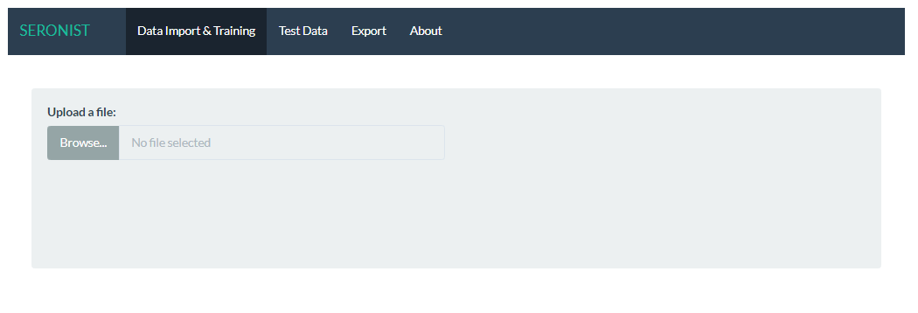Using the Preview Data Table [2], locate the row number that contains your column headers.

**Figure 1.** SeroNIST Start Page. Press on the Browse button to upload a file and begin using the application.

**Import**

1. Under the Import tab, select the header row number in the Column Header Row Select Menu [4]. If there is no header to create column labels from, leave the default selection “No Header”.
   1. Additionally, if your file is an excel file, select the desired sheet from the file using the Excel Sheet Select Menu [3].
2. Once selections have been made, press Load Button [5]. This will render a Raw Data Table [6] to display the data with Pre-Import settings applied.
3. Additional tools will become available once data is loaded, use the Sample ID Column Selector [7] and Metadata Column Selector [8] to track additional metadata throughout SeroNIST.

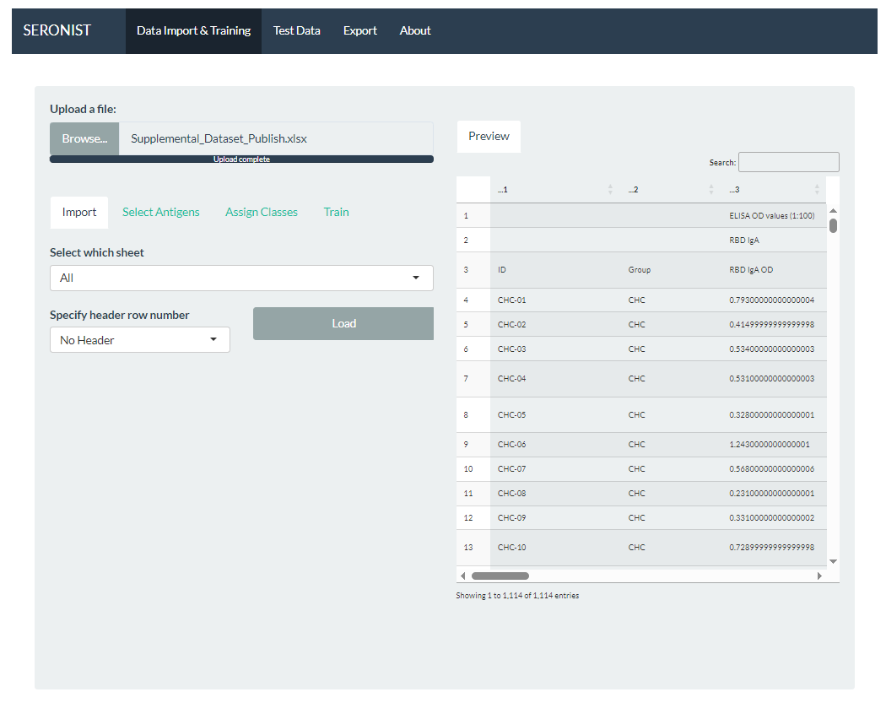

**Figure 2.** User interface that appears after the initial file upload. Import, Select Antigens, Assign Classes and Train tabs become available as well as a Preview data table. Use these to aid in the data acquisition process.

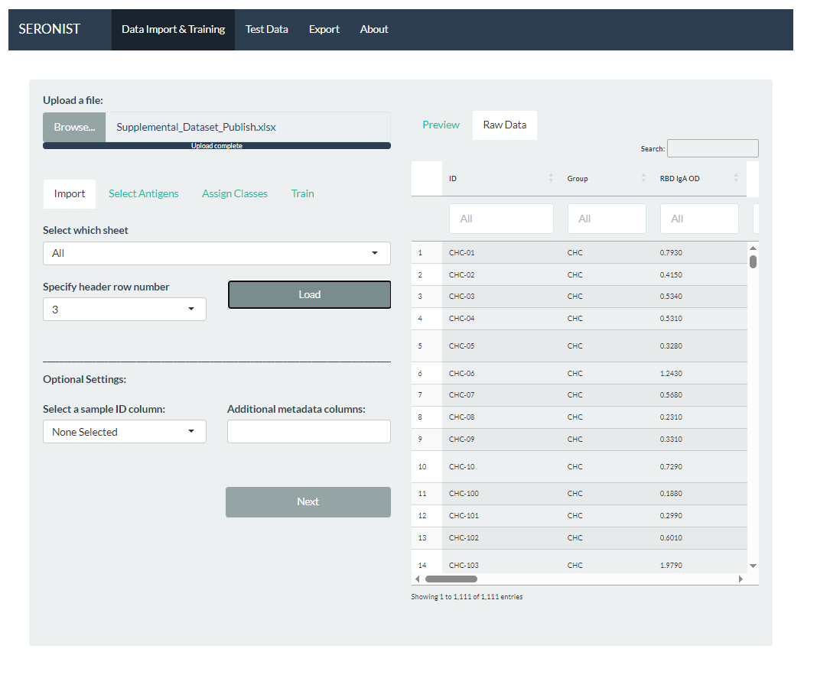

**Figure 3.** Optional settings that render under the Import tab upon loading the pre-filtered data. Additional Raw Data table will appear to the right after applying column header and excel sheet filters.

**Select Antigens**

1. Press the Next Button [9] to advance to the “Select Antigens” tab.
2. Using Number of Antigens Selector [10], select the number of antigens to add.
   1. To filter out non-numeric rows, use the checkbox labeled “Display only numeric columns” in the Numeric Antigen Filter [11].
   2. If the Numeric Antigen Filter is not checked, non-numeric columns of data will be highlighted in red. These columns may still be selected but may have unexpected effects that may result from converting non-numeric data to numeric data.
3. Rows will appear in the Antigen Assign Tool [12], allowing users to assign and modify the name for each individual antigen.
   * 1. Under “Select antigen column”, use the dropdown menu to select a column for the current antigen.
     2. Optionally, users may rename the antigen by typing into the empty textbox under the “Enter antigen name” column.
     3. Antigens may be deleted by clicking the “X”.
     4. To add an additional antigen, follow steps i-iii for the following row.
4. When finished, press the Next Button [13].

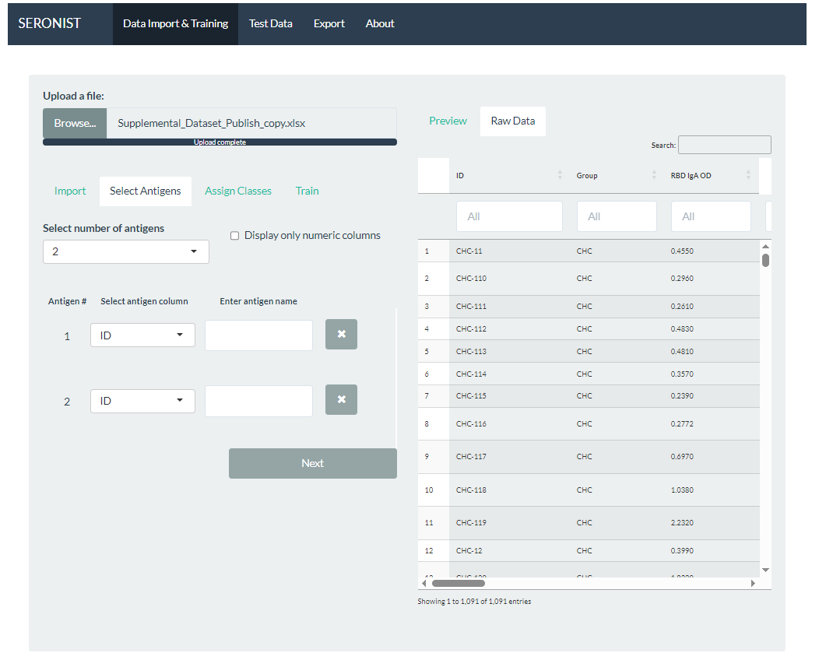**Figure 4.** Selecting Antigens starts by choosing the number of Antigens to assign from the given dropdown menu. Making this selection will render a variable number of rows for users to input metadata for each antigen.

**Assign Classes**

1. Under the “Assign Classes Tab”, use the Class Assign Mode Selector [14] to choose whether to add classes by column, or by manually selecting rows of data from the Raw Data Table [6].
   1. If adding classes by column, use the Class Column Selector [15] to select a single class to add. Users may also combine multiple classes from this tool and combine them into a single class, separated by a colon “;”.
   2. If adding a class by row, select rows of data from the Raw Data Table [6]. The row numbers selected will appear in the Selected Rows Display [16].
2. Once a class is staged to be assigned, press the Add Class [18] button.
3. The added class will appear in the Class Assign Tool [19], which renders a row of tools for each added Class. Under the “Class (# Rows)” column, the selected class is displayed.
4. Optionally, the class can be renamed using the empty text box under “Enter class name”.
5. For Data Import & Training, two classes must be assigned. Adding more or less than two classes may prevent advancing through the pipeline.
6. Press the Submit button [20]. This will render the Selected Data Table [21], the Raw and Log Data Plots [22] and advance to the Train Tab.
   1. If pressing the button has no response, double check that all above steps have been completed.

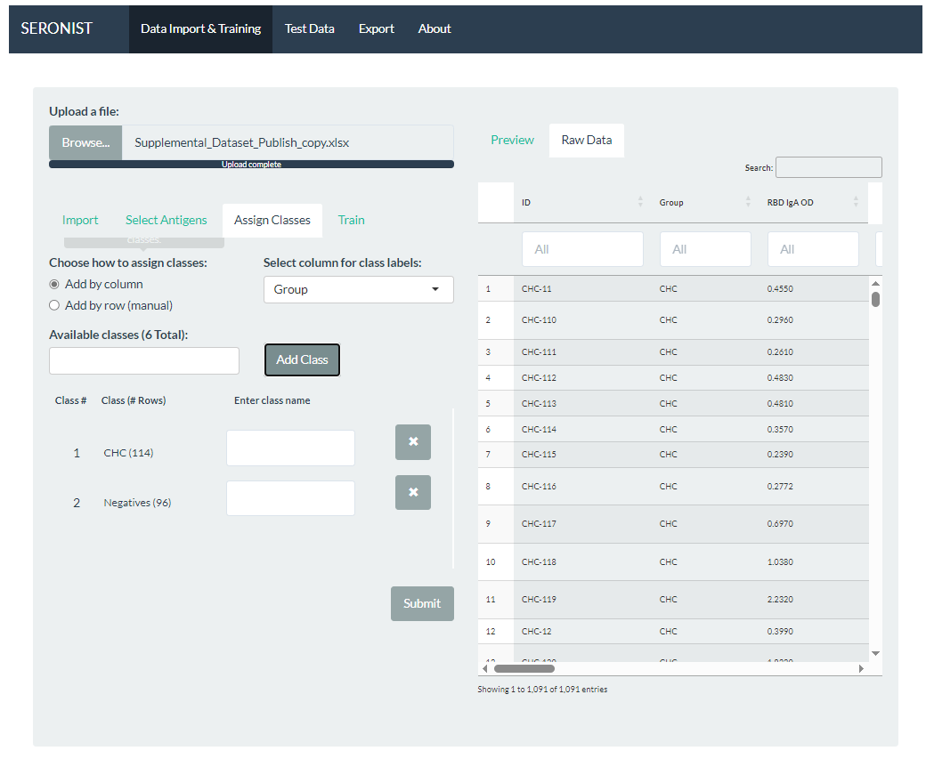**Figure 5.** Classes can be assigned by column or by row by first selecting from the radio button in the top left. This figure displays the user interface you can expect from the first option. Choose which column to use for your groupings, and then add classes individually by selecting them from the Available Classes and pressing Add Class.

**Train**

1. Select from the Data Transformation Mode Selector [23] whether to analyze raw data or log transformed data.
2. Press the Initialize Optimization Button [24]. A progress bar will appear in the bottom right corner and the button will disable until the computation is complete.
3. Upon completion, the Initial Classifier Plot [25], Uniform Uncertainty Bounds [26], and Optiize Classifier for Training Data Button [27] will render.
4. Once complete, press the Optimize Classifier for Training Data Button [27]. Similarly, a progress bar will appear and the button will disable until complete. This completes the analysis pipeline for Data Import & Training.

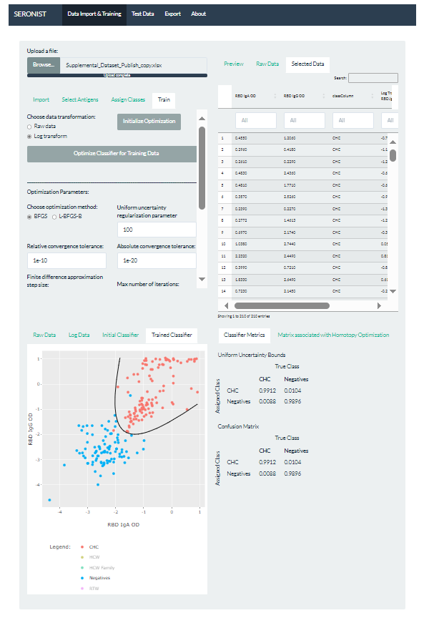**Figure 6**. The Train tab allows users to transform their data before generating an initial and optimized classification boundary over the data. Please wait after each button press on the Train tab to ensure that any backend computations reach completion. Any changes made to upstream steps in the pipeline may result in inconsistent results or changes may not go through. Upon completion, the Trained classifier plot will render along with Classifier metrics and supplementary tables under the Matrix associated with Homotopy Optimization tab.

**Test Data**

1. The Test Data tab is arranged identically to the Data import & Training Tabs. Please refer to the above sections for instructions that correspond to data acquisition steps for File Upload (Pre-Import), Importing, Selecting Antigens and Assigning Classes.
2. When Selecting Antigens, please ensure that the number of antigens remains identical the number of Antigens selected in the Data Import & Training tab.
3. When assigning classes, unlike the Data Import & Training tab, there is no requirement to make a class assignment.
   1. Users may select “None” for the Available Classes Selector [16] or Selected Rows Display [17] if adding by row.
   2. Note: Users may also assign classes as they would in the Data Import & Training Tab, however, this will have no effect on class assignments in the Homotopy optimization routine other than applying a filter for the selected classes to refine the analysis.
4. Once the Test Datafile has been imported, antigens assigned, and classes (optionally) assigned, press the Submit button.
   1. This will render a plot and data table for the selected data and proceed to the Train tab.
5. On the Train tab, press the Optimize Classifier for Test Data Button [40]. A progress bar will appear while the computation takes place. Upon completion, a Classified Data Table [41] will appear as well as updated plot showing the Test Data classification boundary applied to the Training Data.
   1. If the button fails to respond, double check that all previous steps (including those from Data Import & Training) have been completed and meet the requirements.

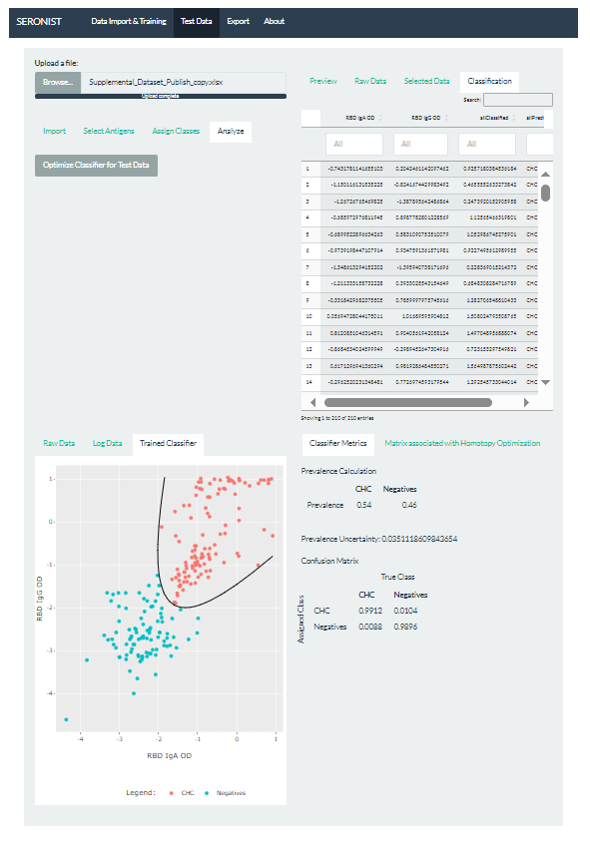**Figure 7.** Test Data tab, Analyze subtab. Previous tabs in the Test Data data acquisition pipeline have been omitted due to their identical formatting to the Data Import & Training Tab. For instructions and visual aids on the Import, Select Antigens, and Assign Classes tabs, please refer to Figures 1 through 6. The Analyze tab for Test Data has a single button that may be pressed upon completion of all upstream steps in the pipeline. Upon completion, a Classification data table will render, along with a Plot of the Trained Classifier being applied over the Training Data. Classifier metrics and supplementary tables are accessible using the tabs in the bottom left.

**Export Data**

1. Once all steps in the pipeline have been completed (Data Import & Training, Test Data), the results may be exported to an Excel file via the Export tab.
2. Press the Brose Export Directory [42] button at the top of the Export tab and select the directory using the window that appears.
   1. Optionally, users may skip this setting. The exported file can then be found in the following directory of the SeroNIST folder:

“SeroNIST/shiny/Exports”

1. Select whether to name the file yourself or by using a default naming convention.
   1. Example of default filename:

“SeroNIST_Export__YYYY-MM-DD_hh-mm-ss_EDT.xlsx”

1. Select what data to export from the dropdown menu, the default being “All of the Above”. This will export the raw data, selected data, classifier metrics, test data, and classifier metrics for test data.

**Description of User Interface**

This section describes each component of the user interface for SeroNIST, including the type, location, directions for use and limitations. Because the Data Import & Training tab and Test Data tab are nearly identical, please refer to the Data Import & Training tab figures to locate the identical interface for the Test Data tab. Where applicable, a Section “f” for Test Data Limitations is added for gui components that may have specific caveats within the Test Data tab.

1. File Upload Button
   1. *Type:*

File Select

* 1. *Locations:* 
     1. Data Import & Training, Top Left
     2. Test Data, Top Left
  2. *Brief Description:*

The browse button allows users to navigate and select the location of datafile(s) for upload to SeroNIST.

* 1. *Directions:*

1. After pressing the button labeled “Browse”, a file explorer window will appear. Use this window to navigate to the location of your data.
2. If uploading a .xlsx file, the Excel Sheet Selector [3] will appear, giving users the option to specify which sheet to upload.
3. To start a new search, upload a new file using the same button. This will overwrite the previous upload and clear all previous work.
   1. *Limitations:*
      1. The file formats supported are .xlsx, .csv and .txt. Excel files may contain multiple sheets.
      2. The file upload button does not check for compatibility of files or correctness of data.
      3. Mixing numeric and non-numeric data within the same column may result in unexpected app behavior.
      4. Uploading an errant file or one that is improperly formatted may cause the application to force close.
      5. Only single file uploads are supported currently.
4. Preview Data Table
5. *Type:*

Data Table, Pre-Import

1. *Locations:* 
   1. Data Import & Training, Preview Tab, Top Right
   2. Test Data, Preview Tab, Top Right.
2. *Brief Description:*

The Preview Data Table is rendered after a file is staged for upload. This table is used to identify Pre-Import settings such as assigning the column header or excel sheet.

1. *Directions:*

See Directions under the Tables section.

1. *Limitations:*

See limitations under the Tables Section.

1. Excel Sheet Select Menu
2. *Type:*

Dropdown Menu, Pre-Import

1. *Locations:* 
   1. Data Import & Training, Import Tab, Left
   2. Test Data, Import Tab, Left
2. *Brief Description:*

The Excel Sheet Select Menu allows users to specify a specific sheet in a .xlsx file for upload.

1. *Directions:*
2. After uploading an .xlsx file, a dropdown menu will appear with the label “Select which sheet”.
3. Click the dropdown menu to view available sheets in the file and select the desired sheet for upload.
4. *Limitations:*
   1. The Excel Sheet Select Menu appears only when excel files are staged for upload using the File Upload Button [1].
   2. At this time, only one Excel sheet may be selected for upload.
5. Column Header Row Select Menu
6. *Type:*

Dropdown Menu, Pre-Import

1. *Locations:* 
   1. Data Import & Training, Import Tab, Left
   2. Test Data, Import Tab, Left
2. *Brief Description:*

The Column Header Row Select Menu allows users to specify a row number within the file upload to indicate where column names are defined. The selected column header is used by SeroNIST to display and assign specific columns throughout the user interface.

1. *Directions:*
2. After uploading a supported file, a dropdown menu will appear with the label “Specify header row number”.
3. Using the Preview Data Table [2], identify the row number where column names of your file are located.
4. Select the number to indicate the row number of the column headers from the dropdown menu.
5. If no column headers exist, keep the default “No Header”.
6. *Limitations:*
   1. The Column Header Row Selector allows the user to assign a row to use for column names in the first 100 rows of the file.
   2. If choosing the “No Header” option, column names will be automatically assigned to your file as “X1”, “X2” and so on.
   3. Subsequent dropdown menus will rely on column headers assigned here to display available columns during data acquisition. If you notice that the resulting dropdown menus don’t display expected values, it is often because an incorrect header row was selected during Pre-import.
7. Load Button
8. *Type:*

Action Button

1. *Locations:* 
   1. Data Import & Training, Import Tab, Left
   2. Test Data, Import Tab, Left
2. *Brief Description:*

The Load Button is pressed to render the Raw Data Table [6] after Pre-Import settings have been selected.

1. *Directions:*
2. Press the Load Button, labeled “Load”, once to apply Pre-Import settings.
3. While the process completes, a progress bar will appear in the bottom right corner to indicate expected wait time.
4. To adjust how the file is imported, make changes to the Pre-Import settings [3, 4] and press the Load Button again. All previous progress will be overwritten.
5. *Limitations:*
   1. Multiple button presses will be queued and responded to sequentially.
   2. Adjusting other settings while the progress bar is incomplete may fail to apply those settings or cause a force close.
6. Raw Data Table
7. *Type:*

Data Table with Filter Boxes

1. *Locations:* 
   1. Data Import & Training, Raw Data Tab, Top Right
   2. Test Data, Raw Data Tab, Top Right
2. *Brief Description:*

The Raw Data Table is rendered once the Load Button [5] is pressed, and applies the Pre-Import settings such as Excel Sheet Select Menu [3] and Column Header Row Select Menu [4].

1. *Directions:*

See Directions under the Tables section.

1. *Limitations:*

See limitations under the Tables Section.

1. Sample ID Column Selector
2. *Type:*

Dropdown Menu, Optional Tool

1. *Location:* 
   1. Data Import & Training, Import Tab, Bottom Left
   2. Test Data, Import Tab, Bottom Left
2. *Brief Description:*

The Sample ID Column Selector is an optional setting that allows users to select a single additional column to assign Sample ID metadata to display in subsequent Tables and Plots.

1. *Directions:*
2. After a file has been loaded, a dropdown menu with the label “Select a sample ID column” will appear under “Optional Settings” in the Import tab.
3. Typically, a Sample ID column should contain values that are unique, such columns will appear with no highlight while columns with non-unique values will appear with a red highlight. Either may be selected.
4. *Limitations:*
   1. The Sample ID column selected here should not be assigned elsewhere.
   2. If the columns available do not reflect the columns expected, double check the specified header row in the Column Header Row Select Menu [4].
   3. Red highlighted columns may still be selected but may not contain a unique identifier for every row present.
5. Metadata Column Selector
6. *Type:*

Dropdown Menu, Optional Tool

1. *Location:* 
   1. Data Import & Training, Import Tab, Bottom Left
   2. Test Data, Import Tab, Bottom Left
2. *Brief Description:*

The Metadata Column Selector is an optional tool that allows users to select one or multiple additional columns of metadata to display in subsequent Tables and Plots.

1. *Directions:*
   1. After a file has been loaded, a dropdown menu with the label “Additional metadata columns” will appear under “Optional Settings”.
   2. Select one or multiple columns as additional metadata.
2. *Limitations:*
   1. Columns selected as additional metadata should not be assigned elsewhere.
   2. If the columns available do not reflect the columns expected, double check the specified header row in the Column Header Row Select Menu [4].
3. Next Button for Import Tab
4. *Type:*

Action Button, Optional Tool

1. *Locations:* 
   1. Data Import & Training, Import Tab, Bottom Left
   2. Test Data, Import Tab, Bottom Left
2. *Brief Description:*

The Next Button for Import tab is pressed to advance to the Select Antigens tab.

1. *Directions:*
2. Press the button labeled “Next” to go to the next step in the pipeline. Alternatively, press any of the data acquisition tabs above to navigate directly to that tab.
3. *Limitations:*
   1. The Next Button is an optional tool with no effect other than advancing to the next tab. There is no previous button.
4. Number of Antigens Selector
5. *Type:*

Dropdown Menu

1. *Locations:* 
   1. Data Import & Training, Select Antigens Tab, Top Left
   2. Test Data, Select Antigens Tab, Top Left
2. *Brief Description:*

The Number of Antigens Selector allows users to specify between one and three antigens to use in analysis.

1. *Directions:*
   1. Using the dropdown menu labeled “Select number of antigens”, choose the number of antigens to add.
   2. A variable number of rows will render below, one row for each antigen.
   3. Selecting one antigen will perform 1D analysis, two antigens will perform 2D analysis, and three antigens will perform 3D analysis.
2. *Limitations:*
   1. Selecting the number of antigens will determine analysis dimensionality.
3. *Test Data Specific Limitations:*
   1. The number of Antigens selected on Data Import & Training tab must match the number of Antigens on the Test Data tab.
4. Numeric Antigen Filter
5. *Type:*

Checkbox

1. *Locations:* 
   1. Data Import & Training, Select Antigens Tab, Top Left
   2. Test Data, Select Antigens Tab, Top Left
2. *Brief Description:*

When assigning antigens in the Antigen Assign Tool [12], the columns available to choose from may be filtered if they contain non-numeric data.

1. *Directions:*
   1. To filter out columns containing non-numeric data, check the box labeled “Display only numeric columns”.
   2. Once pressed, the dropdown menus under “Select antigen column” will exclude columns containing non-numeric data.
   3. View the columns in the Antigen Assign Tool [12] and observe that non-numeric columns are hidden.
   4. If the checkbox is not pressed, the Antigen Assign Tool [12] dropdown menus will display all columns, with non-numeric columns highlighted in red.
2. *Limitations:*
   1. Non-numeric data columns highlighted in red may still be used to assign individual antigens, but may have unexpected effects downstream as the non-numeric data is converted to numeric data.
   2. Non-numeric data may be converted to NA if the data does not have a numeric equivalent.
   3. The Numeric Antigen Filter should reactively update the antigen dropdown menus below. If the change does not apply automatically, try changing the number of antigens in the Number of Antigens Selector [10] and then changing back to the desired number of antigens.
3. Antigen Assign Tool
4. *Type:*

Row(s) containing Text, Dropdown Menu, Text Input Box, Action Button

1. *Locations:* 
   1. Data Import & Training, Select Antigens Tab, Bottom Left
   2. Test Data, Select Antigens Tab, Bottom Left
2. *Brief Description:*

For each antigen, a row of tools will appear. Use each row to assign antigen data, rename the antigen, or remove the antigen here.

1. *Directions:*
   1. Using the dropdown menu under the “Select antigen column”, select a column from the file upload to use for each antigen.
   2. Optionally, use the empty text box in the same row to label the antigen something other than the given column name.
   3. To remove the antigen, press the ‘X’, this will clear the entire row for that particular antigen.
2. *Limitations:*
   1. Selecting a red highlighted column for the antigen may lead to unexpected effects as these columns may contain non-numeric data that are converted to incorrect values or NA.
   2. Once a column has been assigned as an antigen, that same column should not be assigned elsewhere.
3. Next Button for Select Antigens Tab
4. *Type:*

Action Button, Optional Tool

1. *Locations:* 
   1. Data Import & Training, Select Antigens Tab, Bottom Left
   2. Test Data, Select Antigens Tab, Bottom Left
2. *Brief Description:*

The Next Button for Select Antigens Tab is pressed to advance to the “Assign Classes” tab.

1. *Directions:*
2. Press the button labeled “Next” to go to the next step in the pipeline. Alternatively, press any tab above to navigate directly to that step in the pipeline.
3. *Limitations:*
   1. The Next Button is an optional setting with no effect other than advancing to the next tab. There is no previous button.
4. Class Assign Mode Selector
5. *Type:*

Radio Button, Optional Tool

1. *Locations:* 
   1. Data Import & Training, Assign Classes Tab, Top Left
   2. Test Data, Select Antigens Tab, Bottom Left
2. *Brief Description:*

Users are given the option to assign available classes by column or by manual row selection. Selecting one option over the other requires different user input and will render different indicators for assigning classes.

1. *Directions:*
2. Under “Choose how to assign classes”, users may choose to assign classes by column or by row.
3. The option labeled “Add by column” allows users to specify a column in the Class Column Selector [15]. From this column, unique classes are auto-detected and displayed in the Available Classes Selector [16]. Users may select from these available classes to add and assign a specific class.
4. The option labeled “Add by row” allows users to manually select individual rows of data from the Raw Data Table [6]. The selections are displayed in the Selected Rows Display [17].
5. Switching between options will clear previously assigned classes.
6. *Limitations:*
   1. In option “Add by column” a column must be selected from the Class Column Selector [15] menu.
   2. In Option “Add by row”, rows of data must be selected from the Raw Data Table [6].
7. Class Column Selector
8. *Type:*

Dropdown Menu

1. *Location:* 
   1. Data Import & Training, Assign Classes Tab, Top Left
   2. Test Data, Assign Classes Tab, Top Left
2. *Brief Description:*

Users may use this dropdown menu to browse available columns from their data to pull class labels used for class assignment.

1. *Directions:*
   1. Under “Select column for class labels”, change the selected column from “None” to the column containing class labels for the data.
   2. Go to the Available Classes Selector [16] to select from available classes.
2. *Limitations:*
   1. For the Data Import & Training Tab, the column selected cannot be “None”.
   2. The class column assigned here should not be assigned elsewhere, such as for Sample ID, Additional Metadata, or Antigens.
3. *Test Data Specific Limitations:* 
   1. The column selected for class assignments may be optionally left as “None” for the Test Data tab only. Selecting “None” will run the analysis on the entire datafile.
4. Available Classes Selector
5. *Type:*

Multiclass Menu

1. *Locations:* 
   1. Data Import & Training, Assign Classes Tab, Left
   2. Test Data, Assign Classes Tab, Left
2. *Brief Description:*

The Available Classes Selector is used to select one class or combine multiple classes to be staged for assignment.

*Directions:*

* 1. Click on the menu to view available classes from the column chosen in the Class Column Selector [15].
  2. Select one class to add one class, or multiple classes to combine them.
  3. Once the desired class has been selected, click the Add Class button [18].

1. *Limitations:*
   1. Dual assignment of the same class is not supported.
   2. If the Available Classes Selector is not visible, choose “Add by column” from the Class Assign Mode Selector [14] tool.
2. Selected Rows Display
3. *Type:*

Text Output

1. *Locations:* 
   1. Data Import & Training, Assign Classes Tab, Left
   2. Test Data, Assign Classes Tab, Left
2. *Brief Description:*

The Selected Rows Display shows the currently selected rows within the Raw Data Table [6] that are ready to be assigned to a particular class.

*Directions:*

* 1. If the Selected Rows Display is not visible, select the “Add by row” option from the Class Assign Mode Selector [14] tool.
  2. Select rows in any sequence from the Raw Data Table [6].
  3. View the selected rows in the Selected Rows Display as sequences of numbers. Discontinuous sequences will be separated by a semicolon ‘;’.

1. *Limitations:*
   1. Dual assignment of the same rows of data is not supported.
2. Add Class Button
3. *Type:*

Action Button

1. *Locations:* 
   1. Data Import & Training, Assign Classes Tab, Left
   2. Test Data, Assign Classes Tab, Left
2. *Brief Description:*

Press the Add Class button to assign a class that is currently staged for addition. This will render additional tools below to modify metadata associated with the added class.

1. *Directions:*
   1. Once a class is staged for addition from either the Available Class Selector [16] or the Selected Rows Display [17], press the button labeled “Add Class”.
   2. For each class added, a row of user inputs will appear below, allowing you to view the added class and modify metadata associated with it.
2. *Limitations:*
   1. At least two classes must be added before continuing to view and plot the selected data.
   2. If the limit for added classes has been reached, the Add Class Button will not have an effect.
   3. Classes added with the “Add by row” option will appear as the sequence of row numbers as they were selected. They can be renamed using tools described below.
3. Class Assign Tool
4. *Type:*

Row(s) containing Text, Dropdown Menu, Text Input Box, Action Button

1. *Locations:* 
   1. Data Import & Training, Assign Classes Tab, Bottom Left
   2. Test Data, Assign Classes Tab, Bottom Left
2. *Brief Description:*

For each class, a row of tools will appear. Use each row to view the assigned class label, rename the antigen, or remove the antigen here.

1. *Directions:*
   1. Under the “Class (# Rows)” column, view the label of the added class that was just assigned. The number of rows associated with the particular class are displayed in parentheses.
   2. Optionally, use the text box under “Enter Class name” to rename the class.
   3. To remove the class, press the ‘X’ button, this will clear the entire row for that class.
2. *Limitations:*
   1. The columns used to assign antigens, Sample ID, or additional metadata should not be reused for class assignment.
   2. Classes added using the “Add by row” option from the Class Assign Mode Selector [ ] are automatically renamed to “Class 1”, “Class 2”, etc. if no rename is provided.
   3. A minimum of two classes is required to continue.
3. Submit Button for Assign Classes Tab
4. *Type:*

Action Button

1. *Locations:* 
   1. Data Import & Training, Assign Classes Tab, Bottom Left
   2. Test Data, Assign Classes Tab, Bottom Left
2. *Brief Description:*

The Submit Button for Assign Classes Tab is pressed to advance to the “Train” tab as well as render plots and tables associated with the selected data.

1. *Directions:*
2. Once all Import settings, Antigen data and Class assignments have been made, press the Submit button.
3. A progress bar will appear in the bottom right corner while the app applies your settings and renders additional tables and figures.
4. If no response occurs, double check that all previous steps in the pipeline have been completed and meet the requirements for continuing.
5. *Limitations:*
   1. Changes made to settings or tools that are upstream of the Submit button will not be recognized by the downstream interface until the Submit button is pressed.
   2. Multiple button presses will be queued and responded to sequentially.
   3. Adjusting other settings while the progress bar is incomplete may fail to apply those settings or trigger a force close.
6. Selected Data Table
7. *Type:*

Data Table with Filter Boxes

1. *Locations:* 
   1. Data Import & Training, Selected Data Tab, Top Right
   2. Test Data, Selected Data Tab, Top Right
2. *Brief Description:*

The Selected Data Table is rendered after a file is uploaded, antigens and classes have been assigned, and the Submit button [20] has been pressed. This table will display the filtered data resulting from the user’s chosen settings.

1. *Directions:*

See Directions under the Tables section

1. *Limitations:*

See limitations under the Tables Section.

1. Raw and Log Data Plots
2. *Type:*

Interactive Plot

1. *Locations:* 
   1. Data Import & Training, Raw Data Tab, Log Data Tab, Bottom Left
   2. Test Data, Raw Data Tab, Log Data Tab, Bottom Left
2. *Brief Description:*

The Raw or Log Data Plots render by pressing the Submit Button [20] under the Assign Classes Tab. This plot displays the selected data in an interactive window that can be maneuvered to different views, hovered for individual datapoint metadata, or downloaded to your device.

1. *Directions:*

See Directions under the Plots Section.

1. *Limitations:*

See Limitations under the Plots Section.

1. Data Transformation Mode Selector
2. *Type:*

Radio Button, Optional Tool

1. *Location:*

Data Import & Training, Train Tab, Top Left

1. *Brief Description:*

Under “Choose data transformation”, you are given the option to choose which type of data transformation to apply to the data prior to analysis, either with the Raw data or log transformed data.

*Directions:*

1. Under “Choose data transformation”, selecting the default value “Raw Data”, will use data in its raw format for the analysis routine.
2. Choosing the option labeled “Log Transform” will apply a log transformation to the data for the analysis routine.
3. Switching between options will automatically display the corresponding plot from the Raw and Log Data Plots [22].
4. *Limitations:*
5. Initialize Optimization Button
6. *Type:*

Action Button

1. *Location:*

Data Import & Training, Train Tab, Top Left

1. *Brief Description:*

Pressing the Initialize Optimization Button performs the initial steps for the Homotopy optimization routine by guessing a boundary for the initial classifer, plotting that initial classifier, and displaying Uniform uncertainty bounds over the data.

1. *Directions:*
2. Press the Initialize Optimization Button.
3. A progress bar will appear in the bottom right corner and the button will disable until the computation is complete.
4. Upon completion, the Initial Classifier Plot [25] will be rendered as well as the Uniform Uncertainty Bounds [26] table.
5. *Limitations:*
   1. Modifying upstream settings during or after completion of the optimization routine will fail to apply those changes.
6. Initial Classifier Plot
7. *Type:*

Interactive Plot

1. *Location:*

Data Import & Training, Initial Classifier Tab, Bottom Left

1. *Brief Description:*

The Initial Classifier Plot is the first of two plots resulting from pressing the Initialize Optimization Button [24]. This plot displays the selected filtered data with an initial classification boundary.

1. *Directions:*

See Directions under the Tables section

1. *Limitations:*

See limitations under the Tables section.

1. Uniform Uncertainty Bounds
2. *Type:*

Table Ouptut

1. *Location:*

Data Import & Training, Classifer Metrics Tab, Bottom Right

1. *Brief Description:*

Uniform Uncertainty Bounds contains metrics that describe the maximum expected uncertainty for this optimization.

1. *Directions:*
   1. Click on the tab labeled “Classifier Metrics”.
   2. The Uniform Uncertainty Bounds appear as the first table under this tab.
   3. The columns refer to the True class, while rows refer to the Assigned class.
2. *Limitations:*
3. Optimize Classifier for Training Data Button
4. *Type:*

Action Button

1. *Location:*

Data Import & Training, Train Tab, Left

1. *Brief Description:*

Pressing this button performs the remaining Homotopy optimization routine by computing an optimized classification boundary, plotting the trained classifier, and displaying a confusion matrix and supplementary Matrices associated with Homotopy Optimization table.

1. *Directions:*
2. Once an initial classifier has been computed, press the Optimize Classifier for Training Data Button.
3. A progress bar will appear in the bottom right corner and the button will disable until the computation is complete.
4. Upon completion, the Trained Initial Classifier Plot [28] will be rendered as well as the Confusion Matrix and Matrix associated with Homotopy Optimization [30].
5. *Limitations:*
6. Adjusting other settings while the progress bar is incomplete may fail to apply those settings or trigger a force close.
7. Trained Classifier Plot
8. *Type:*

Interactive Plot

1. *Location:*

Data Import & Training, Trained Classifier Tab, Bottom Left

1. *Brief Description:*

The Trained Classifier Plot is the second of two plots resulting from pressing the Optimize Classifier for Training Data Button. This plot displays the filtered data with an optimized classification boundary.

1. *Directions:*

See Directions under the Tables section

1. *Limitations:*

See limitations under the Tables section.

1. Confusion Matrix for Training Data
2. *Type:*

Table Ouptut

1. *Location:*

Data Import & Training, Classifer Metrics Tab, Bottom Right

1. *Brief Description:*

The Confusion Matrix for Training Data displays the relative performance of the trained classifier resulting from the homotopy optimization routine, displaying classification accuracy for true versus assigned class and displaying false positive and false negative rates in the off-diagonals values.

1. *Directions:*
   1. Click on the tab labeled “Classifier Metrics”.
   2. The Confusion Matrix for Training Data table appear as the second table under this tab.
   3. The columns refer to the True class, while rows refer to the Assigned class.
   4. Diagonal values can be interpreted as the accuracy of classifying this class.
   5. Off-diagonal values are interpreted as, from left to right, the false positive and false negative rates respectively.
2. *Limitations:*
3. Matrices Associated with Homotopy Optimization and Associated Parameters
4. *Type:*

Supplementary Table Navigator

1. *Location:*

Data Import & Training, Matrix associated with Homotopy Optimization Routine Tab, Bottom Right

1. *Brief Description:*

This table displays the boundaries determined along each major step of the Homotopy optimization routine in matrix form.

1. *Directions:*
   1. Click on the tab labeled “Matrix associated with Homotopy Optimization Routine”.
   2. To view each matrix, press the button labeled “Matrix Viewer”. This will advance to the next boundary in the optimization routine.
   3. Matrix number, the Sigma value used and the Objective function output (L) will update with the respective matrix.
   4. To revert back to the first Matrix, press “Start Over”.
2. *Limitations:*
3. Optimization Method Selector
4. *Type:*

Radio Button, Optional Setting

1. *Location:*

Data Import & Training, Train Tab, Optimization Parameters

1. *Brief Description:*

This tool allows users to choose between the standard BFGS quasi-Newton method or a faster performing L-BFGS-B method.

1. *Directions:*
   1. Select BFGS to run a quasi-Newton method
   2. Select L-BFGS-B to use a limited-memory modification of the BFGS quasi-Newton method, for faster performance but potentially less precision.
2. *Limitations:*
3. If non-trivial bounds are supplied, the method selected by default will be L-BFGS-B.
4. Uniform Uncertainty Regularization Parameter
5. *Type:*

Numeric Input, Optional Setting

*Location:*

Data Import & Training, Train Tab, Optimization Parameters

1. *Brief Description:*
2. *Directions:*
3. *Limitations:*
4. Relative Convergence Tolerance Parameter
5. *Type:*

Numeric Input, Optional Setting, “reltol” Parameter

1. *Location:*

Data Import & Training, Train Tab, Optimization Parameters

1. *Brief Description:*

The algorithm stops if it is unable to reduce the value by a factor of ‘reltol * (abs(val) + reltol)’ at a step.

1. *Directions:*
   1. Enter a value for Relative Convergence Tolerance between 1e-16 and 1e-2.
   2. The default value is 1e-10.
2. *Limitations:*
3. Absolute Convergence Tolerance Parameter
4. *Type:*

Numeric Input, Optional Setting, “abstol” Parameter

1. *Location:*

Data Import & Training, Train Tab, Optimization Parameters

1. *Brief Description:*

The absolute convergence tolerance is a tolerance for reaching zero.

1. *Directions:*
   1. Enter a value for Absolute Convergence Tolerance between 1e-25 and 1e-2.
   2. The default value is 1e-20.
2. *Limitations:*
3. The absolute convergence tolerance is only useful for non-negative functions.
4. Finite Difference Approximation Step Size Parameter
5. *Type:*

Numeric Input, Optional Setting, “ndeps” Parameter

1. *Location:*

Data Import & Training, Train Tab, Optimization Parameters

1. *Brief Description:*

A vector of step sizes for the finite-difference approximation to the gradient, on ‘par/parscale’ scale.

1. *Directions:*
   1. Enter a value for the Finite Difference Approximation Step Size between 1e-12 and 1e-2.
   2. The default value is 1e-8.
2. *Limitations:*
3. Max Iterations Parameter
4. *Type:*

Numeric Input, Optional Setting, “maxit” Parameter

1. *Location:*

Data Import & Training, Train Tab, Optimization Parameters

1. *Brief Description:*

Allows users to specify the maximum number of iterations in the optimization routine.

1. *Directions:*
   1. Enter a value for the number of max iterations between 1 and Infinity.
   2. The default value is 1e4.
2. *Limitations:*
3. Convergence Tolerance Control for L-BFGS-B Parameter
4. *Type:*

Numeric Input, Optional Setting, “pgtol” Parameter

1. *Location:*

Data Import & Training, Train Tab, Optimization Parameters

1. *Brief Description:*

This parameter allows users to help control the convergence of the L-BFGS-B method and is a tolerance on the projected gradient in the current search direction.

1. *Directions:*
   1. Enter a value for the convergence tolerance control between 1e-25 and 1e-2.
   2. The default is 1e-16.
2. *Limitations:*
3. Convergence Control for L-BFGS-B Parameter
4. *Type:*

Numeric Input, Optional Setting, “factr” Parameter

1. *Location:*

Data Import & Training, Train Tab, Optimization Parameters

1. *Brief Description:*

Controls convergence of the L-BFGS-B method. Convergence occurs when the reduction in the objective is within this factor of the machine tolerance.

1. *Directions:*
   1. Enter a number for convergence control between 0 and Infinity.
   2. The default value is 1e1.
2. *Limitations:*
3. Optimization Parameter Restore Default Button
4. *Type:*

Action Button, Optional Setting

1. *Location:*

Data Import & Training, Train Tab, Optimization Parameters, Bottom Left

1. *Brief Description:*

This button resets all optimization parameters to their defaults.

1. *Directions:*
   1. If users have made changes within the session to any optimization parameters, press this button to restore default settings.
   2. Users may achieve the same results of this button press by closing SeroNIST and starting a new session.
2. *Limitations:*
3. Pressing this button only resets non-default optimization parameters.
4. Any previous changes to optimization parameters will be lost upon button press.
5. Optimize Classifier for Test Data Button
6. *Type:*

Action Button

1. *Location:*

Test Data, Analyze Tab, Left

1. *Brief Description:*
2. *Directions:*
3. Once an optimized classifier has been computed for the Data Import & Training tab, and data acquisition steps (Import, Select Antigens, Assign Classes) on the Test Data tab, press the Optimize Classifier for Training Data Button.
4. A progress bar will appear in the bottom right corner and the button will disable until the computation is complete.
5. Upon completion, the Trained Initial Classifier Plot [28] will be rendered as well as the Confusion Matrix and Matrix associated with Homotopy Optimization [30].
6. *Limitations:*
7. Changes made to settings or tools that are upstream of the Initialize Optimization button will not be recognized by the downstream interface until the Initialize Optimization button is pressed.
8. Adjusting other settings while the progress bar is incomplete may fail to apply those settings or trigger a force close.
9. Pressing this button will overwrite downstream steps in the optimization routine and clear previous work downstream of the pipeline.
10. Pressing this button may be disabled or cause a force close if previous steps in data acquisition have not been completed.
11. Browse Export Directory
    1. *Type:*

Directory Select, Optional Setting

* 1. *Locations:* 
     1. Export Tab, Top Left
  2. *Brief Description:*

The Browse Export Directory button allows users to select a pathway on their local or external device as the export location. The Directory select also allows users to create subfolders within their selected path.

* 1. *Directions:*

1. After pressing the “Browse” button, a file explorer window will appear. Use this window to navigate to the location you wish to export to.
2. The left panel displays the path, while the right panel displays contents of the folder (if any) selected in the left panel.
3. Select the desired pathway in the left panel.
   * Optionally, use the “Create new folder” button in the top left to add a subfolder within the currently highlighted folder.
   * If exporting to any newly created subfolders, don’t forget to select them so that they are highlighted.
4. Once your selection has been made, press “Select” in the bottom left.
   1. *Limitations:*
      1. Folders created within this window must adhere to file naming requirements of your operating system.
5. File Naming Mode Selector
6. *Type:*

Radio Button

1. *Location:*

Export Tab, Left

1. *Brief Description:*

Choose between a default naming convention or enter a name yourself. If

1. *Directions:*
   1. Decide whether you would like to name the file yourself or with a default naming convention.
   2. Example of default filename:“SeroNIST_Export__YYYY-MM-DD_hh-mm-ss_EDT.xlsx”
2. *Limitations:*
3. If entering a file name manually, the file name must exclude the following characters: \ / : * ? “ < > |
4. If entering a file name manually, ensure that the file name is not identical to any previously created files in the same directory. Doing so may stop the export process or overwrite the previous file.
5. Export File Name Entry
6. *Type:*

Text Box

1. *Location:*

Export Tab, Left

1. *Brief Description:*

The Export File Name text box allows users to enter a file name manually in this empty text box.

1. *Directions:*
   1. From the File Naming Mode Selector [42] under “Choose file name”, select the option labeled “Enter name”. This will enable the Export File Name text box.
   2. Type the file name, keeping in mind file naming limitations of your operating system.
2. *Limitations:*
3. For Windows devices, the file name must exclude the following characters:

\ / : * ? “ < > |

1. Select Data to Export Menu
2. *Type:*

Dropdown Menu

1. *Location:*

Export Tab, Bottom Left

1. *Brief Description:*

This dropdown menu allows users to specify which subset of data to export. The default is to export “All of the Above”.

1. *Directions:*
   1. Open the dropdown menu and make a single selection.
2. *Limitations:*
   1. At this time, users must complete all previous steps in the pipeline (Data Import & Training, Test Data) before being able to export.
   2. At this time, users may only export “All of the Above”.
3. Select File Format Menu
4. *Type:*

Dropdown Menu

1. *Location:*

Export Tab, Bottom Right

1. *Brief Description:*

This dropdown menu allows users to specify the file type of the export. Choices include .xlsx and .txt.

1. *Directions:*
   1. Open the dropdown menu and make a single selection.
2. *Limitations:*
   1. Currently, users are limited to .xlsx file extension.
3. Export Button
4. *Type:*

Action Button

1. *Location:*

Export Tab, Bottom Right

1. *Brief Description:*

Pressing this button initiates the export after applying the settings selected above.

1. *Directions:*
   1. Once all steps in the pipeline have been completed, including Data Import & Training, Test Data, and Export settings, press this button.
   2. Locate the folder selected as the export location.
   3. Locate the newly exported file within the export location.
2. *Limitations:*
   1. This button will not activate unless all stages in the pipeline have been completed. This includes Data Import & Training, and Test Data.
   2. In the absence of an export path, the file will be exported to the following path within the SeroNIST download folder:

“SeroNIST/shiny/Exports/”

**Plots**

1. *Directions:*
2. Hover over the plot to view a toolbar in the top right of the plot. These individual tools can be hovered to display their purpose.
3. Hover over individual data points within the plot to display metadata associated with that point, including antigen and class assignments and optional Sample ID or metadata columns that may have been added.
4. To zoom, press and drag to create a bounding box.
5. Double click to reset to the original view, or use the tools in the toolbar.
6. To download, hover over the plot toolbar and press the camera icon to download the plot to your Downloads folder.
7. To display additional data that may have been filtered out using the Class Assign Tool [19], press on the grayed out class of interest in the legend.
8. *Limitations:* 
   1. Data displayed are autoscaled to the nearest bounds for each axis.
   2. The download format for plot downloads is .PNG.
   3. At this time, hovertext may display duplicate metadata.
   4. Axes limits, class color, and plot orientation may vary between plots along the same pipeline.
   5. Significant figures displayed in hovertext metadata info are for display purposes only and do not reflect the raw number of significant figures used in analysis.

**Tables**

1. *Directions:*
2. Press on the double arrow next to each column header to sort in ascending or descending order numerically.
3. Enter text into the Search box in the top right corner to filter results from the displayed table.
4. Use filter boxes under each column to search that column specifically.
5. Scroll vertically or horizontally to navigate the rows and columns from the data.
6. *Limitations:*
   1. Significant figures of numeric data displayed do not reflect the precision of the data imported.
   2. Once data is imported, the raw number of significant figures are used in analysis.
   3. Once a column is sorted using the column sorter, the original order of the table cannot be displayed without uploading the file again. Alternatively, use the fixed left-column containing row numbers to view the original ordering.